Prediction of performance measures in Incremental Sheet Forming



Student Name
Adnan Hussain
2014-IED-MSc-IE/PT-07

Supervisor

Dr. Wasim Ahmad
Associate Professor

Department of Industrial Engineering,
Faculty of Industrial Engineering
University of Engineering & Technology, Taxila, Pakistan
April 2018

A thesis submitted in partial fulfilment of the requirements for the degree of M.Sc. Industrial Engineering

Adnan Hussain
2014-IED-MSc-IE/PT-07

Supervisor
Dr. Wasim Ahmad
Associate Professor

External Examiner’s Signature: ________________________

Thesis Supervisor’s (Internal): __________________________

DEPARTMENT OF INDUSTRIAL ENGINEERING
FACULTY OF INDUSTRIAL ENGINEERING
UNIVERSITY OF ENGINEERING AND TECHNOLOGY TAXILA
2018

ABSTRACT
Although Incremental sheet forming has inherent advantages of low cost for low volume production, though its suffer great limitations in terms of its formability, surface roughness and geometric accuracy. It has been reported that for industrial requirements, the geometric accuracy and surface finish of the formed part must lie within 0.2mm and 3µm respectively. Incremental sheet forming on the other hand can achieve not less than 3mm deviation and worse surface finish. For overcoming these limitations, current research target to address this limitation.
This has been achieved by performing and evaluating incremental sheet forming at two conditions i.e, at elevated temperature and at room temperature. The comparison of both the conditions has been achieved by performing experiments and developing empirical relationships as per central composite design. The developed empirical models were validated by six additional experiments and the percentage error was found less than 7% for instances which shows that the developed models can be used for prediction. Furthermore, the effects of heat on performance measures have also been compared on two different conditions of incremental sheet forming i.e. support and without support.
The findings of this results show that most significant factor affecting surface roughness is step depth followed by spindle speed and lastly among three parameters being discussed is feed. Surface roughness increases significantly on increase in step depth. The comparison of surface roughness under heat and no-heat conditions reflects that surface roughness achieved for ISF under heat condition is better than no-heat condition for most of the experimental conditions.
The reduction due to heating of workpiece during ISF reduces the surface roughness ranging from 6%~48%. This high percentage reduction clearly demonstrates the superiority of ISF under heated condition. Minimum surface roughness achieved is 0.65µm- under heat condition.
Furthermore, it has also been found that most significant factor affecting geometric accuracy is step depth followed by spindle speed and lastly among three parameters being discussed is feed. The comparison of Geometric deviation under heat and no heat condition reflects that geometric accuracy is better for ISF under heat condition better than no-heat condition for majority of experimental conditions. Once comparison is drawn for geometric accuracy with and without back plate under heat condition, superior geometric accuracy was achieved for most of the experimental conditions employing back plate under heat. Minimum value of geometric deviation achieved is 3.79% under heat condition with back plate.

UNDERTAKING

I certify that research work titled “Prediction of performance measures in Incremental Sheet Forming ” is my own work. The work has not been presented elsewhere for assessment. Where material has been used from other sources it has been properly acknowledged / referred.

Adnan Hussain
2014-IED-MSc-IE/PT-07

ACKNOWLEDGEMENT

First of all I would like to thank my supervisor Dr Wasim Ahmad whose efforts and guidance helped me achieve this feat. It was only possible due to his kind, motivational, worthy and thought provoking remarks. He was always there to provide a valuable feedback to his students which made the research work whole lot of easier.
I would also like to thank my teacher Prof. Dr Mirza Jahanzaib, who boosted my self-esteem every time they got a chance and supported me throughout my time period in the university. They were always there for students and occasionally went out of the way to help their dear students which for me set an example and made my research experience enjoyable. At the end I owe my thanks to the seniors and the friends who kept me on track throughout my tenure.

DEDICATION

To my parents who never lost the patience.

Adnan Hussain
2014-IED-MSc-IE/PT-07

Table of Contents
ABSTRACT III
UNDERTAKING IV
ACKNOWLEDGEMENT V
DEDICATION VI
CHAPTER 1 1
1.1 Introduction 1
1.2 Research Background 1
1.3 Research Motivation 2
1.4 Aims and Objectives 3
1.5 Scope of Research 4
1.6 Applications of Sheet Forming 4
1.7 Organization of Thesis 4
2 CHAPTER 2 6
2.1 Introduction 6
2.2 Forming processes 6
2.2.1 Classification of forming processes 6
2.3 Incremental sheet Forming Parameters 10
2.4 Performance measures 12
2.4.1 Surface roughens 12
2.4.2 Factors affecting dimensional accuracy 13
2.5 Research on Hot Incremental Forming 13
2.6 Range of Material Used 14
2.7 Research Gap 20
2.8 Summary 20
3 CHAPTER 3 21
3.1 Introduction 21
3.2 Research Methodology 21
3.3 Work piece and its preparation 21
3.4 Experimental setup 23
3.5 Selection of process Parameters and Ranges 25
3.6 Design of Experiment 27
3.7 Performance measures 28
3.8 Summary 31
4 CHAPTER 4 32
4.1 Introduction 32
4.2 Development of mathematical models 32
4.2.1 Mathematical Model for surface roughness 32
4.2.2 Mathematical model for dimensional accuracy 36
4.3 3D response surface plots 42
4.3.1 Response surface plot of surface roughness without heat 43
4.3.2 Effect of process parameters on surface roughness under heat 44
4.3.3 Effect of process parameters on Dimensional Accuracy with back plate under No heat condition 46
4.3.4 Effect of process parameters on Dimensional Accuracy without back plate (no-heat) 48
4.3.5 Effects of process parameters on Dimensional Accuracy with with back plate under heat condition 50
4.3.6 Effect of process parameters on Dimensional Accuracy without back plate (with heat) 52
4.4 Validation 54
4.5 Comparison of Results 54
4.5.1 Comparison of Surface roughness under heat and no-heat conditions 54
4.5.2 Comparison of Geometric deviation under heat and under no Heat 55
4.6 Summary 57
5 CHAPTER 5 58
5.1 Introduction 58
5.2 Conclusions 58
5.3 Future Recommendations 59
6 References 60

CHAPTER 1
Introduction

Introduction
This chapter comprises of research background including the relevant motivation, aim, objective and scope for research. Application of Incremental Sheet forming and thesis organization will be the last part of chapter.

Research Background
A large number of industrial products find their way processed through sheet metal forming techniques. Products obtained through Incremental Sheet Forming (ISF) have a superior qualitative edge, in a ready to use condition with minimum geometric inaccuracies. Such techniques can be employed to achieve a cost-effective product being part of larger batches within the given time constraints and employing minimum requirement of replacing the existing tools/ machine setup. An agile and adoptive system requires minimum cost of quick changes dictating the prototype finalization. Through effective employment of ISF, low production batches or personalized prototypes naturally very expensive through traditional stamping processes can be managed in a minimum time. In R&D and eventually once asserting the overall life cycle of the product, small batch products or customized prototypes are manageable through Sheet forming process economically.
Setup of ISF can be used for a wide variety of products without significant changes which increases the likelihood of its employment in coming years.
ISF is closely related to numerous other processes being employed in manufacturing industry. Two of the processes namely conventional spinning and shear spinning are forming processes that can be closely linked with ISF but have some fundamental differences in tool employment and sheet thickness being achieved. Spinning procedure is based upon work piece clamped to a rotating mandrel the spinning tool movement deforms it by means of several increments for axisymmetric products only ([1, 2]. Conventional spinning product is formed through a series of extensive strokes with a forming tool. Shear spinning employs the permanent contact of tool with the work piece [3]For conventional spinning the final thickness is kept constant while in shear spinning the thickness is considerably reduced due to stretching mechanisms with the mould in the rotating mandrel depicting the final shape of the product [4].
Owing to the growing interests in ISF due to its application in industry, many patents and developments have been achieved on subject. The R&D is at rise due to its numerous applications, primarily employing the flexibility offered by the process.
Iseki and co-workers can be declared as the pioneers in the process [10,11]. Initial development was based upon utilizing three-dimensional tool paths in a simplified manner. Gradual improvement in CNC milling machines further added to the scope of research in ISF process [6,9]. With advent of new CNC machines in market, the capability for the agile production of asymmetric sheet metal parts was developed. In the very beginning, ISF was performed employing basic CNC milling machines. A close relevance with existing ISF was depicted by Mason in 1978 [5]for production in small batch customization with the application of a unique spherical tool having numerical control in three axes. Further improvement in CNC machines was a contributing factor in achievements in sheet forming technique. The evolution in ISF was more intensive since 90’s and new variants were developed and patented [5]. Hence ISF process are based strongly on automation and Digital data. To setup the process in start, required part is designed in CAD-software. CAD model then form the basics to create the preliminary trajectory using CAM-software. While the forming trajectory is further re evaluated to suit the needs and dimensions of the forming platform. At the end, required part is achieved through a clamped piece of sheet metal while eliminating the requirement of any further support.

Research Motivation
Using the Sheet forming process in manufacturing industry, the component can be directly formed from the CAD software to enable the time factor brought to minimum along with required dimensional accuracy. While having the cost effectiveness parameter in mind, new prototypes can be easily developed and further improvement is also possible employing the rapid prototype parts for finalization of product or to produce small number of parts in sheet metal or in polymer. Changes in Geometry or process parameters are welcomed and are being easily implemented with the component sizes limited to the machine table size. Such changes on the component design can also be rapidly incorporated by modifications in CAM file. For simple geometries, the chain from the design table to end state can be in relatively less time. On work floor, it may be termed as idealized situation and usually some simple support setups are necessary. ISF operation is quiet and relatively without noise abolishing most of the environmental and safety hazards. Cost of tool for experimental setup is one of the most important contributors denying the new changes in a batch or meeting the exact requirements, ISF does not emphasize for expensive tools, i.e., punch and die. However, a backing plate can be used to achieve an angle change near the clamped region with any conventional CNC milling machine being adopted. It may be termed as comparatively fast and swift procedure in the production industry. Whole idea of ISF revolves around layer-by-layer forming whereby the geometric configuration is sliced into a group of forming contours stacked on top of each other. Traditionally, forming is performed in layers followed by a vertical step down (z) before the next contour. Trajectory may also be helical, i.e. the forming tool is constantly moving downwards resulting in a relatively smoother surface finish.
Although Incremental sheet forming has inherent advantages of low cost for low volume production, though its suffer great limitations in terms of its formability, surface roughness and geometric accuracy. It has been reported that for industrial requirements, the geometric accuracy and surface finish of the formed part must lie within 0.2mm and 3µm respectively. Incremental sheet forming on the other hand can achieve not less than 3mm deviation and worse surface finish. For overcoming these limitations, current research target to achieve the following aim:

Aims and Objectives
Aim of the current research is to enhance accuracy and surface roughness of Incremental sheet forming process.
Objective of the current research includes
- Identification of the incremental sheet forming strategies to improve performance measures.
- Experimental setup design for carrying incremental sheet forming.
- Carrying out alternative strategy (heated workpiece) to enhance the state performance measure.
- Modeling of performance measures (surface roughness and accuracy) using statistical technique.
- Investigation of effects of process parameters on performance measures.
- Comparing and evaluating sheet forming under heat and no heat conditions for achieving better performance measures.

Scope of Research
Scope of this research is to find the interaction between accuracy and surface roughness of the material being formed on overall Sheet forming process in two conditions. Interaction of relevant process parameters will be studied while having ISF in room temperature and same will be evaluated under heat. Prime focus will be on development of a predictive model to enable the forecasting of roughness and accuracy of material and to study the material behavior under heat and at room temperature.

Applications of Sheet Forming
ISF can be employed in a number of sophisticated prototype and small batch productions assignments to attain geometric accuracy and economy both. Low cost time constraint order with highest precision and accuracy being achieved through employment of ISF is the hallmark of this technique. Though largely dependent on how the operator utilizes his skill for modeling in CNC, ISF has its application from a basic part to be offered in industry till the obsolete parts being made as per requirement of customers if the batch production of any such part has already been ceased even years ago.

Organization of Thesis
The organization of the thesis is as follows:
Chapter 1 covers the need for incremental sheet forming, motivation of the current research on incremental sheet forming, aims and objectives of the research and scope of current research.

Chapter 2 Outlines the literature review of sheet forming, which is categorized with respect to the various parameters of incremental sheet forming, material used for ISF, techniques being employed to reduce surface roughness and to improve the dimensional accuracy and reducing spring back effect.
The research methodology, selection of workpiece material, selection of working range of input parameters and performance measures, strategy to improve dimensional accuracy, experimental setup and design and performance measures have been presented in chapter 3.
Chapter No.4 covers the analysis of results, development of mathematical model, and
validation of mathematical models. Results comparison and establishing the optimum
values enlist the last part.
Finally, conclusions of the research along with research findings and future recommendations have been presented in chapter 5.

CHAPTER 2

Introduction
The Chapter will elaborate the basics alongwith classification of Sheet forming techniques and summary of the previous research conducted. Quality of the product obtained through sheet forming depends largely on forming tool path, material being used, tool radius, feed rate and spindle speed as important forming parameters. While desired performance parameters are surface finish, dimensional accuracy, wall angle, desired thickness of wall and forming time required. Literature review in this chapter will discuss various forming processes in practice to improve quality of final product in most efficient manner.

Forming processes
Centuries ago, if you were a cook looking to purchase new utensil you would had looked for a skilled blacksmith. Selected blacksmith may had used his hammer with other simple tools shaping an initially flat sheet into basic utensil. Focusing on improvement in production procedure, it can be imagined that the blacksmith will start by warming the sheet then start hammering it, afterwards he may use a rod with a round tip to create a proper curvature that can fulfill the requirement. For those customers who could had afforded more, blacksmith may offer more finance to create a unique work piece. Without the advent of incremental sheet forming, the improvements were not possible denying basics involved in it. Therefore, Incremental forming is similar to several other processes like ring hammering, rolling, spinning and stamping.

Classification of forming processes
Forming finds its roots deep in hammering. The difference between many forming processes is mainly on basis of contact made by the tool that can be permanent or temporary in nature.
Sheet metal processes widely categorized in basic categories are as under:

2Cutting
Includes Shearing to separate large sheets, blanking to cut part perimeters out of sheet metal and Punching to make holes in sheet metal.

Bending
It is the process in which metallic sheets are shaped using V- bending or edge bending techniques.

Drawing
Forming of sheet into convex or concave shapes is the major characteristic of drawing technique.

Hammering
It is considered as one of the oldest forming technique, during the early days done manually but with the passage of time now being performed with CNC machines as shown in figure 2.1(a) and figure 2.1(b). Most advanced Hammering processes takes edge of the robotic technology and employs a robotic arm that supervise tool movement and punches the sheet, clamped in a support frame, moving in predefined circular path descending step by step in each round.
Fig 2.1(a) Incremental hammering Scheme Figure 2.1(b) Industrial Robot

Spinning
It can be further divided in two different types, i.e., Conventional spinning and Shear spinning as shown in figure 2.2(a) and figure 2.2(b).

Figure 2.2 (a) Conventional Spinning of a cone using multiple pass ( b) Shear Forming of a cone using single pass.

Parts are gradually formed over a mandrel using a rounded tool or roller in Conventional Spinning. Typically used equipment resembles to a lathe machine where the metal sheet is clamped in a mandrel and whole setup is resolved. Tool piece applies a localized pressure to deform the blank by axial and radial motions over the surface of the part. Tool may be manual or mechanically driven, with a low tool cost, this process is suitable for small series parts requiring least steps to prepare a final product. Shear Spinning is similar to Conventional Spinning method with the difference of stretching instead of bending the work piece resultantly affecting the final thickness of work piece wall.

Stamping
In this process thin walled metal parts are obtained by employing punches and dies mounted on mechanical or hydraulic presses. Especially designed tools for stamping processes are termed as hard tools. Stamping is normally performed by employing single die station or multiple die station for high batch products. On the basis of presses being used, two wide categories can be distinguished in stamping process Mechanical and hydraulic presses. Mechanical press has a mechanical flywheel which stores energy and then transfers it to a punch to form the part ranging in capacity from 20 tons up to 6000 tons. Strokes have a range from 5 to 500 mm and speed from 20 to 1500 strokes per minute. Mechanical presses are vastly employed during high-speed blanking, shallow drawing and to attain precision parts. Hydraulic presses with a controlled force have a varying range from 20 tons to 10,000 tons. Strokes vary from 10 mm to 800 mm. Hydraulic presses are better suited for deep-drawing, forming or coining. Tooling cost including constant sharpening of tool during the process is a certain disadvantage in employing the hydraulic press. One of the disadvantages of this process is the high tooling cost as in order to increase the tool or punch life it has to be constantly sharpened along with the cost related to the die which increases the overall tooling cost.

Sheet Metal Forming
For applications requiring moving bodies including aerospace and automotive, lightweight materials are of main interest. One of the most crucial goal to improve the performance of these moving masses is to reduce weight. Aluminum alloys are light weight material characterized by superior characteristics including fatigues performances, fracture toughness and strength to density ratio. These Aluminum alloys are characterized by high strength to density ratio. The formability of these alloys is usually low. Sheet metal forming is one of the most important fabrication method involving in the manufacturing of parts. The conventional sheet forming methods rely on punches and dies. As the high cost of the manufactured dies and punches are distributed among high number which make it suitable for mass production. For small number of parts, these conventional methods become unsuitable. In the present technologically advanced era, small batch production is required by many industries including aeronautics automotive, prototyping and biotechnology. This emphasizes on need of new and flexible methods suitable for small batch production methods. Among these techniques, incremental sheet forming has the advantage of reducing the fixed and capital fabrication cost for small batch productions [6]. Incremental sheet forming does not require dedicated expensive equipment [7]. A comprehensive potential and state of the art of incremental sheet forming has been described by Jeswiet et. Al [3]
In incremental sheet forming, the desired geometry as defined a 3D cad model is formed by envelopment of a tool at all the relative positions defined in the cad model to deform a clamped blank. The schematic of incremental sheet forming is shown in figure 2.3.The resultant part will be produced with zero set-up cost practically [8, 9]. Flexibility of the ISF method is high due to the fact that to make a new product, only program is needed to be modified making the minimum lot size to one [9]. This can allow for manufacturing old parts whose production has been discontinued [10]. Furthermore, formability is larger than the conventional processes including stamping [11] However, incremental sheet forming has some limitations. For a wider industrial use, it is necessary to find solutions to these main limitations including geometric accuracy, process time, surface roughness, sheet thinning and lack of modeling tools [12, 13]

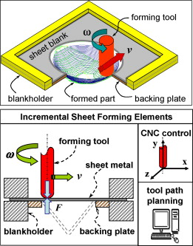
Figure 2.3: Schematics of ISF

Incremental sheet Forming Parameters
As mentioned earlier, main limitations of ISF includes geometric accuracy, surface roughness, sheet thinning and lack of modeling tools. On completion of forming, once loads removed, an undesirable shape change occurs due to spring back deformation creating deviations from desired shape. For traditional sheet metal forming, spring back occurs on removal of load due to large contact area between the forming tools and sheet during the process. While in ISF, three spring back phenomenon occurs during ISF. Initial with the displacement of the tool, known as continuous local spring back. Second named as global spring back on load removal and dismounting from clamps while last occurs on trimming (if done) also known as global spring back after trimming [12]Other inaccuracies like sheet bending effect, pillow effect along with spring back effect are shown in figure 2.4. The sheet bending is near the base of the part and can be reduced by using a back plate. The spring back effect is produced when the punch is relaxed; the blank lifts up resulting in a lower final depth of the part than desired. Pillow effect is encountered at the minor base of the part resulting in a concave part. Thinning in ISF depends on wall angle α according to sine law as is presented in equation 1 [12]
$t_{1}=t_{0}\sin\left(90- α\right)$ (1)
Where t₁ is the final wall thickness and t_{o} is the initial wall thickness. For parts with wall angles exceeding 65 degrees, multistage methods (several intermediate shapes before the final part shape) need to be adopted to avoid failure of part due to excessive thinning[[14]. Thus this forming method cannot be used for complicated parts [15]
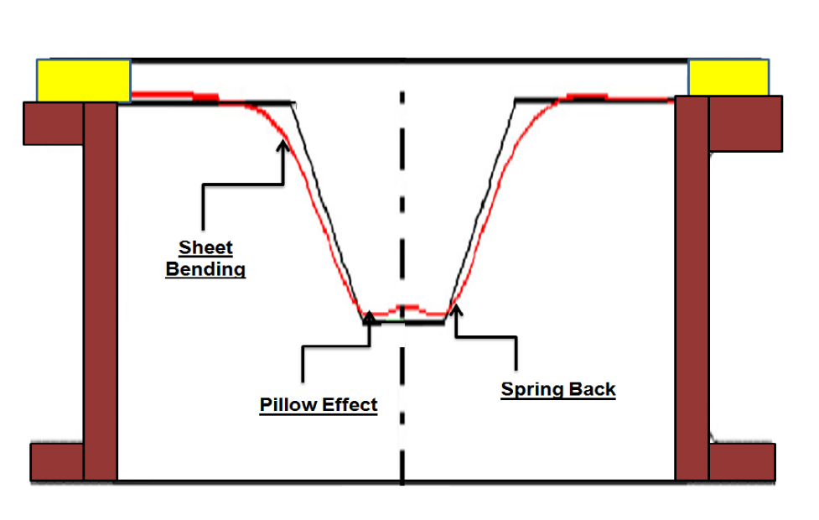

Figure 2.4: Spring back, Pillow and Sheet bending effects

The performance measures (surface roughness and geometric accuracy) depends on the process parameters. The process parameters include tool radius, step size, spindle speed, feed rate, lubricant, sheet thickness. Proper selection of these process parameters can affect the performance measures [1, 16-18]. In literature there exists investigation of effect of process parameters on different performance measures by various researchers.

Performance measures

Surface roughens
Surface roughness depicts the measure of the texture of finished part’s in while assessing its quality, which can be expressed in terms of vertical deviations compared to the designed form. In ISF two widely used parameters are average roughness (Ra) and the parameter of maximum roughness (Rz) to evaluate roughness. In order to achieve a better surface finish a number of parameters are used during sheet forming including tool rotation, forming tool used, feed rate, tool path and step size.

Tool rotation
Silva et al. [29] after having changes in tool speed, feed rate and step size depicted that highest quality parts can be produced with complex geometry and minimum time as he highlighted that feed rate below 1200 mm/min and step depth of 0.2 mm has yielded rough surfaces as compared with that obtained at a higher speed of 8400mm/min for SAE 1008 Steel. Cerro et al. [3]evaluated surface roughness of Al 1050-0 sheet in feed rate and for step size. He established that roughness values are lower for feed rate direction then to the step size. Out of the two cases he evaluated, surface roughness for first case (feed rate lower) was 0.3 μm and in the second case (step size lower) was 0.6 μm. However, while comparing independently surface roughness can be reduced by reducing the step size. A study was carried out by Durante et al. [19]by using a rotating tool as compared with a non-rotating one to evaluate the effect of tool rotation, with changing speed and direction. Results showed that roughness values decreased by 10 percent on giving tool rotation and direction in clockwise and counterclockwise direction.

Tool size and materials
Forming tool material and size are considered important in surface roughness and studies were conducted by some researchers for selecting a suitable material and its
diameter. Ham et al. [20]] employed acetal tipped and a carbide tool to evaluate forming aluminum sheet surface finish in which acetal tool achieved better surface finish. An experimental study conducted by Bhattacharya et al. [39] on the surface finish of Al5052 showed that the surface roughness increases with an decrease in tool size for all incremental depths. In order to achieve a better surface finish, feature-based algorithm
against conventional ISF tool path method can be employed. It utilizes a dedicated program using profile milling code and converting them into helical tool path allowing continuous feed in all three directions, which was researched by Skjoedt et al. [[4]].

Step size
Increase in incremental step increases the surface roughness. White light interferometry scan used by Hagan and Jeswiet [3]to perform surface roughness tests of CNC ISF for different incremental depths established that maximum peak-to-valley height increases exponentially with increase in the ste. In order to understand the effects of different sheet forming process variables on surface roughness of Al5052, a study was conducted by Bhattacharya et al. [1, 12]which showed that surface quality decreases first with increases in step size depth up to a certain angle and after reaching a certain point it increases.

Factors affecting dimensional accuracy
Literature review indicates that spring back is mostly affected by sheet metal thickness, feed rate, spindle speed and incremental depth. Oleksik et al. [1]depicted that springback increases with increase of the tool size and decrease of the step size and sheet thickness. While Mehdi et al. [5]found that reduction in spring back by increasing tool diameter, feed rate, spindle speed and sheet thickness with a reduction in vertical step. Junchao et al[2] established that with increase in number of forming stages, spring back also increases. Further, effect of incremental wall angle on springback was not significant.

Research on Hot Incremental Forming
During ISF, two components of forces appear over horizontal plane (Fx and Fy) and while (Fz) as over the vertical plane. All the three forces can be changed by manipulating the input process parameters, like a decrease in step size will subsequently decrease the forming force as well and a greater degree of springback. Duflou et al. [3, 16]used laser beam for having a heat spot in the moving contact zone between the tool and sheet enabling a reduction in force during the process which resulted in better accuracy and minimized spring back. Pohlak et al. [19]studied effects of residual stresses on geometry of the formed part which depicted that increasing stretching force allows an accurate part. While a high stretching force causes additional sheet necking problems. Therefore, different types of heat treatment have been recommended in literature to reduce residual stresses enabling a part obtained with a lesser degree of springback.

Range of Material Used
Low-temperature forming technology offers a new potential for forming operations of aluminum wrought alloys. Therefore, large amount of work reported in literature for sheet forming process is based around light metals particularly aluminum alloys. Majority of experimental combinations used were mostly of heat-treatable alloys, which were also investigated for enhancement in mechanical properties after completion of process under heat.
The alloy belongs to heat-treatable 2xxx series, precipitation hardening and with relatively higher copper and magnesium contents. Al 2019 develops highest strength and also possess tremendous fatigue resistance allowing its use suitable in high speed moving parts and aerospace industry. Surface finish along with its machine ability properties provides an additional edge for research purpose using this alloy [[6].

From the literature review, it is also revealed that the researchers used different mathematical and statistical methods tools to investigate and model the effect of process parameters on performance measures including Taguchi, grey relational, RSM, CCD, Artificial neural network, finite elements method, conventional and analytical. A comprehensive literature review representing the effect of process parameters on performance measures has been presented in table 2.1. From the detailed literature review, it is evident that no or very little work has been carried out on comparison, modeling and optimization of surface roughness and spring back effect on heated and non-heated Al 2019 alloy prepared through ISF. The present research aims to fill this gap.

Table 2.1: Summary of literature review to identify materials, process parameters, performance measures and modeling techniques used by researcher in ISF
S.No. | Author | Material | Input parameters | Performance parameters | Technique Employed | Tool Type | Sample Shape
01 | CrinaRadu 2011 [21] | DC01 mild steel sheet (0.6mm thickness) | Tool radius, step size, speed rate and spindle speed | Dimensional accuracy and surface roughness | Taguchi L16 array | Spherical tool | Double frustum cone & double  pyramid frustum
02 | Jigar R. Patel 2015 [22] | Aluminiun of grade IS  19000 (0.9 mm thickness) | Wall angle, step size, feed rate and spindle speed | Surface roughness | Taguchi-Grey Relational | Stainless Steel (SS-304) 62 HRC with hemispherical tip | Frustum cone
03 | Anjali ShrikantMulay[2] | Aluminum alloy AA1100 | Tool radius, step size, feed rate and spindle speed | Surface finish and wall thickness | Taguchi | Hemi-spherical head | Frustum cone
04 | PandivelanChinnaiyan[[16] | AA5052 sheet (thickness 1.5mm) | Tool type, sheet thickness, feed rate, vertical step down, tool diameter, spindle speed, lubricant | Formability  Surface roughness | Taguchi based grey relational | EN 08 Steel-- hemispherical end and ball end | Straight groove
05 | Vishal Gulati[[1] | Aluminium-6063 alloy | Tool radius, step size, sheet thickness, tool rotational speed, feed rate, lubrication | Wall angle  Surface roughness | Taguchi | HSS  2 x diff dia hemispherical tip tools | Frustum cone
06 | Wisam K [23] | Aluminum alloy 1060 (thickness 1.2mm) | Forming tool radius, vertical tool pitch, feed rate, support type | Forming time | Taguchi l18 array | (HSS) tool  Hemispherical head. | Frustum cone
07 | P.B.Uttarwar[18] | AA 1100 | Wall angle, feed rate, spindle speed, and step increment | Surface roughness  Wall thickness | Taguchi L9 array | - | Square based pyramid
08 | HoseinMohammadi[24] | Aluminium alloy 1050 | Tool radius, vertical step size, and friction coefficient | Spring back  thickness  Min vertical force | FEM,Taguchi based ANN | Cylindrical high-speed-steel (HSS) tool  with a hemispherical head | Square based pyramid
09 | Zhaobing Liu [25] | AA7075-0 alloy | step over, feed rate, sheet thickness and tool  radius | Forming time | Taguchi | Steel tools with a tungsten carbide hemispherical head | Frustum cone
10 | [26]Suresh Kurra | FEM | Dia, depth, angle | Force, thinning | FEM+ L9 Taguchi | - | Conical part
11 | Zhaobing Liu [17] | AA7075 aluminum alloy | Multistage forming  Part dia (120mm to 140mm)  Draw angle  Part height (6mm to 30mm) | Formability  Thickness reduction | Conventional | Tungsten carbide with hemi spherical head | Cylindrical cup
12 | Mohamed Azaouzi[4] | - | - | Machining time reduction | FEM | - | -
13 | M. Durante [27] | Aluminium 7075-T0 | tool radius, the vertical step and the slope angle | Surface roughness | Analytical/ conventional | Hemispherical tool | Square frustum
14 | Gabriel J. [2] | Aluminium 1100 (thickness 1 mm) | Tool radius, spindle speed, step size, feed | strain | Conventional | Hemispherical tool | Cone frustum
15 | Anderson Daleffe[28, 29] | Titanium F67 Grade 2 (thickness 0.5mm) | Step size, spindle speed, wall angle | Thickness, roughness | Conventional | Hemispherical tool | Square frustum
16 | Khalid A. Al-Ghamdi [29] | Aluminium AA1060 | Sheet thick-  ness (to), step size (p), wall angle (θ), and flow stress (σ)  besides the tool radius | Force | RSM | Hemispherical tool | Square frustum
17 | GiuseppinaAmbrogio1 [[30]] | Brass, Aluminium, AA 1050, HSS | Formed shape (square, coned, flower frustum)  Material | Thickness reduction  Slope angle | ANN | Hemispherical tool | -
18 | Kurra Suresh [31] | EDD steel (thickness 1mm) | Formed shapes (circular, elliptical, parabolic) | Fracture depth  Limiting wall angle  thickness | Conventional/FEM | Hemispherical EN 36 material, 60 HRC | -
19 | Guoqiang Fan [32] | Ti–6Al–4V (thickness 1mm) | Effect of heating | Spring back, pillow and bending effect | Conventional/ FEM | - | Square frustum
20 | H. Khalatbari[5] | Aluminium AA3003-H12 | Tool tip radius, step-size, feed rate, spindle speed, blank thickness | Formability, machining time | RSM | Hemispherical | Conical frustum
21 | G. Hussain[19] | Aluminium AA-2024O | Sheet thickness, tool radius | Wall angle | D Optimal design | Hemispherical | Conical frustum
22 | Paramo Gabriel [2] | Aluminium 1100 | Tool radius , step size | Forming angle | Conventional | Hemispherical | Conical frustum
23 | Salah B. M. [33] | Aluminium AA1050-O | Vertical step size, forming tool radius, spindle speed, and feed rate | Surface roughness | Taguchi | Hemispherical | Conical frustum
24 | YANLE LI [13] | Aluminium 7075-O | Tool size | Failure depth, friction coefficient, thickness | Conventional/ FEM | Hemispherical | Conical frustum
25 | Matthieu Rauch[20] | aluminium alloy (5086) | Feed rate  Tool path shape  Axial increment | Accuracy  Forming time  Forming force | Varience analysis | Hemispherical head tool | Square frustum
26 | G. Ambrogio[7] | Aluminium AA2024-T3, magnesium  AZ31B-O and titanium Ti6Al4V alloys | Current and temperature | Inclination angle  Surface roughness | Conventional | Punch tip – Mild Steel | Conical frustum
27 | G. Centeno[6] | AA1050-H111 | Predefined/ Precut Shape | Formability | Conventional | Single point forming tool - 20WV4-DIN steel | Conical frustum
28 | I. Cerro [34] | Al 1050-0 | Overlapping the incremental steps | Surface roughnrsss  Formability  Force required | FEM/ conventional | Hemispherical tool | Square frustum
29 | F. Micari[9] | Al 1050-O | Flexible support  Counter pressure  Multiple incremental forming  Back drawing incremental forming | Geometric Accuracy | Conventional | Multiple tools | -
30 | GiuseppinaAmbrogio[30] | aluminum  alloys, AA1050-O, AA6082-T6, and AA5754 | Tool federate | Surface roughness  Part accuracy | FEM/ Conventional | Hemishperical tool | Conical frustum
31 | M. Bambach[12] | DC04 mild steel sheets | Perform corner radius | Accuracy | Conventional | - | Square frustum

Research Gap
From literature review, it can be established that very little work has been reported to study effect of heat on improving surface roughness and geometric accuracy in sheet forming process. The available research on using heat to increase accuracy and surface finish is limited to laser heating and heating by making anode cathode arrangement for the current to flow. In both these works, the heat is not controllable and thus the influence of heat on the performance measures is not systematically analyzed. It is also evident from table 2.1 that a mathematical model for relationship between feed, spindle speed and step depth for heated sheet forming is not available for Al 2219.

Summary
The chapter provides a brief description of the various forming processes. It also elaborates overview of sheet forming process and previous research completed in
this field. The effect of sheet forming parameters on Al sheet alloy surface roughness and geometric accuracy is also discussed. Temperature, spindle speed, feed rate and step depth are the significance process input parameters in during ISF. All the given parameters have an influence towards quality of sheet forming product. Various modeling tools used by researchers to observe effect of input parameters sheet forming is also discussed. The gap identified from the literature review in section 2.7 will be addressed in the later chapters. In the following Chapter No.3, the author presents the materials and toolings, research methodology and experimental details for current research.

CHAPTER 3

Experimental Details

Introduction
The chapter will focus on experimental details. These include research methodology, material and its composition, research strategy, selection of process parameters and their ranges, development of experimental setup and measurement of responses.

Research Methodology
The research methodology followed during experimentation is depicted in figure3.1. Input parameters and the onward ranges for these parameters have been selected through literature review. Input parameters for feed, speed and depth were maintained for each experiment to study the behavior of part product spring back effect and surface resistance with heated and non-heated condition. RSM is used to analyze the responses. The experiment was designed as per RSM. Two types of experimental (eighteen) runs have been conducted, one at normal room temperature, while the other one was based on performing the sheet forming on a controlled temperature of 360 C. Quality of formed part was evaluated by spring back effect and the minimum surface roughness achieved. Based on the difference of output parameters during the heated and non-heated process, results were analyzed (Chapter 4). Recommendations for future research work are given at the end (Chapter 5).

Work piece and its preparation
Aluminum 2219(Al 2219) has been used for incremental sheet forming due to its extensive use in high temperature and structural strength component. Al 2219 alloy has copper as the primary additive with wrought Al. Melting temperature of Al 2219 is 543 ºC. This alloy being an aluminum-copper alloy has high strength is less corrosion resistant. It possesses good machine ability properties. It is widely employed in space boosters, fuel tanks, high temperature structural applications in the aerospace sector including supersonic aircraft skin and structural members. Space Shuttle Standard Weight Tank are also fabricated from the same alloy. This alloy is commonly formed by both extrusion and forging. The verified chemical composition of the selected Alloy Al2219 has been provided
Figure 3.1: Research Methodology

For incremental sheet forming, frustum pyramid has been selected to produce as designed shaped. The dimensions of the pyramid was 90x110x35mm (Lx W x H). Work piece of size 200x200mm were extracted for the experiments (figure 3.2).
Table 3.1 Chemical composition of Al2219
Percentage
Material | Aluminum, Al | Copper, Cu | Manganese, Mn | Zirconium, Zr | Vanadium, V | Titanium, Ti
 | 93 | 6.3 | 0.3 | 0.18 | 0.10 | 0.06

For incremental sheet forming, frustum pyramid has been selected to produce as designed shaped. The dimensions of the pyramid were 90x110x35mm (Lx W x H). Work workpieces were then polished with polishing wheel to remove rust and other foreign particles layer. To avoid chances of affecting accuracy due to residual stresses, workpieces were then annealed by soaking it in furnace at a temperature of 399 ºC for one hour. It is then cooled in furnace at a control rate of 28ºC.hour to 260ºC and then was air cooled to room temperature. The annealing helps to remove the residual stresses produced in it due to cold working.
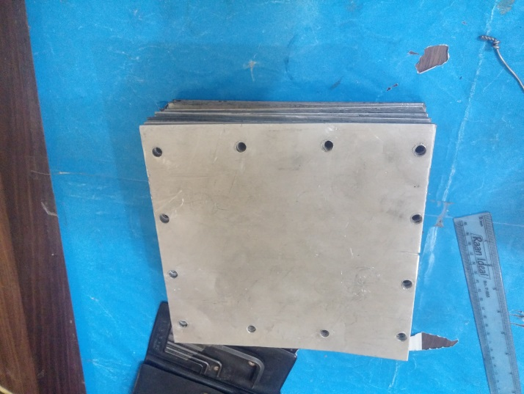
Figure 3.2 Work piece after polishing and annealing

Experimental setup
The experimental setup consists of clamping arrangement, tool, sheet and heating arrangement. The clamping arrangement has been designed for easy clamping and unclamping the workpiece. The location of the forming region was carefully selected to ensure two sides of the workpiece are formed with support plate while for the remaining two side without back plate (figure 3.3).
A hemispherical rotating tool made of high carbon steel having length of 70 mm and 10mm diameter was used. To investigate the effect of heat on surface roughness and accuracy, sheet forming was at elevated temperature was also carried out along with at room temperature. The temperature for investigations under heating was used as 360ºC. The reason behind using this temperature value is that in current research the idea of forming at elevated temperature was adopted from hot forming in which temperatures are kept at 60 percent of melting point (60% of melting point of Al2219 is 324 ºC. The temperature was controlled using PID control setup. The heating of the plate is ensured by a spring loaded heater just beneath the workpiece capable of moving down with the tool downward motion. The schematic of the heating arrangement along with heater has been shown in figure 3.4(a).
Figure 3.3 Region of workpiece for forming pyramid shape

The developed system ensures that the heating of the workpiece can be carried out safely unlike other proposed systems in literature in which large current is passed for heating. The complete experimental setup consists of clamping arrangement, tool, sheet and heating arrangement has been shown in figure3.5

Figure 3.4(a) Schematic of heating arrangement, (b) Spring loaded heater
The machine used for the experiments was Intellitek pro Light 1000 machining center. The machine codes were generated by using PTC Wildfire. The cross section of the part is shown in figure 3.6

Selection of process Parameters and Ranges
From the literature it has been identified that Incremental sheet forming significantly depends on step size, feed rate and spindle speed. Other researchers have investigated forming angle and forming depth as the input process parameter, but these are not controllable process parameter, and hence are not considered in the current research.
The parameters ranges for the selected process parameters have been selected from literature review and screening experiments. The screening experiments were carefully run in such a way the parts obtained are in acceptable quality level. The process parameters along with their ranges have been provided in table 3.2
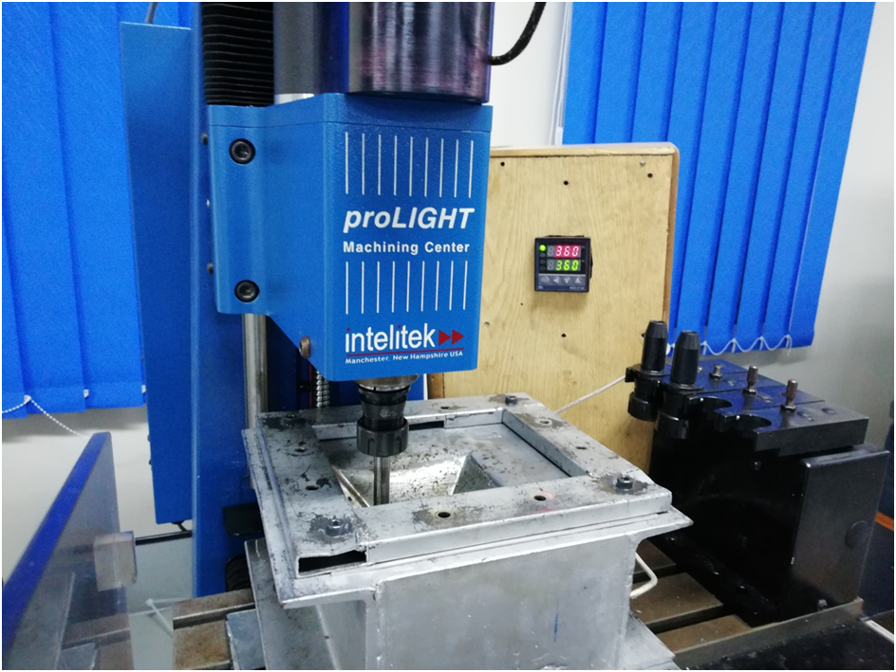
Tool
Clamping arrangement
Work piece
Temperature controller
Figure 3.5 Experimental setup for Incremental sheet forming
Figure 3.6 cross section of the forming sketch
Table 3.2 Process parameters ranges for experimental design
Process parameters | -α | Low | Middle | High | +α
Spindle Speed | 1056.17 | 1500 | 2150 | 2800 | 3243.83
Feed | 152.85 | 250 | 392.50 | 535 | 632.16
Step depth | 0.148 | 0.25 | 0.4 | 0.55 | 0.65

Design of Experiment
RSM based on Central Composite design has been used for design, conduction and analysis of the models. In central composite design, the number of experiments can be calculated by using the following equation.
No. of experiments = 2n+2n+nc
where n is the number of process parameters and nc is the number of experiments on centre points. The number of center points can be between four to six. For the current research, four center points were used. The total number of experiments for the current research is thus eighteen. Overall thirty six experiments were conducted. Eighteen experiments were conducted with heat and other eighteen were conducted without heat. The experiments were conducted in the random order shown by run number in table 3.3 and the responses were observed
Table3.3 Experimental design for ISF under heat and no heat conditions

Std Order | Run | Spindle Speed | Feed | Step Depth | Surface roughness |  | Geometric Deviation
 |  |  |  |  |  |  | Back plate | Back plate | No plate | No plate
 |  |  |  |  | With heat | Without heat | with heat | Without heat | With heat | Without heat
 |  | rpm | mm/min | mm | mm | mm | mm | mm | mm | mm
11 | 1 | 2150 | 152.8445 | 0.4 | 1.504 | 1.67 | 4.2 | 6.2 | 7.65 | 8.5
1 | 2 | 1500 | 250 | 0.25 | 1.091 | 2.1 | 5 | 6 | 8.57 | 8.3
16 | 3 | 2150 | 392.5 | 0.4 | 0.928 | 0.72 | 3.81 | 6.9 | 8.84 | 8.7
5 | 4 | 1500 | 250 | 0.55 | 1.115 | 1.328 | 5.07 | 7 | 8.35 | 8.56
3 | 5 | 1500 | 535 | 0.25 | 1.514 | 1.18 | 5.1 | 6.3 | 7.23 | 8.16
2 | 6 | 2800 | 250 | 0.25 | 1.051 | 0.65 | 5.2 | 6.05 | 7.39 | 8.8
4 | 7 | 2800 | 535 | 0.25 | 0.97 | 1.52 | 4.6 | 7 | 7.02 | 8.36
9 | 8 | 1056.835 | 392.5 | 0.4 | 0.957 | 1.207 | 5.5 | 6.17 | 8.55 | 8.85
10 | 9 | 3243.165 | 392.5 | 0.4 | 1.48 | 1.92 | 4.5 | 5.73 | 7.93 | 8.94
8 | 10 | 2800 | 535 | 0.55 | 0.981 | 1.386 | 4.1 | 5.42 | 8.2 | 8.45
12 | 11 | 2150 | 632.1555 | 0.4 | 1.195 | 2.26 | 4.5 | 6.23 | 7.79 | 8.5
7 | 12 | 1500 | 535 | 0.55 | 0.813 | 1.355 | 6 | 5.8 | 8.55 | 8.75
17 | 13 | 2150 | 392.5 | 0.4 | 1.409 | 1.57 | 3.79 | 6.84 | 8.9 | 8.7
14 | 14 | 2150 | 392.5 | 0.652269 | 1.164 | 1.565 | 5.15 | 6.5 | 8.13 | 8.12
15 | 15 | 2150 | 392.5 | 0.4 | 1.11 | 1.402 | 3.9 | 6.78 | 8.93 | 8.65
13 | 16 | 2150 | 392.5 | 0.147731 | 1.496 | 1.64 | 5.35 | 6.6 | 7.09 | 7.99
18 | 17 | 2150 | 392.5 | 0.4 | 1.007 | 1.322 | 3.88 | 6.8 | 8.79 | 8.8
6 | 18 | 2800 | 250 | 0.55 | 0.693 | 0.739 | 3.56 | 6 | 7.15 | 8.5

Performance measures
As already mentioned, values of two performance measures were measured of the final part namely surface roughness and geometric accuracy (geometric deviation). Surface Roughness was measured on MituToyo SJ-410 Surface Roughness Tester as shown in figure 3.6. For consistency, three readings were taken at randomly chosen locations (for both heated and non heated parts) on the part and average was observed as final value.

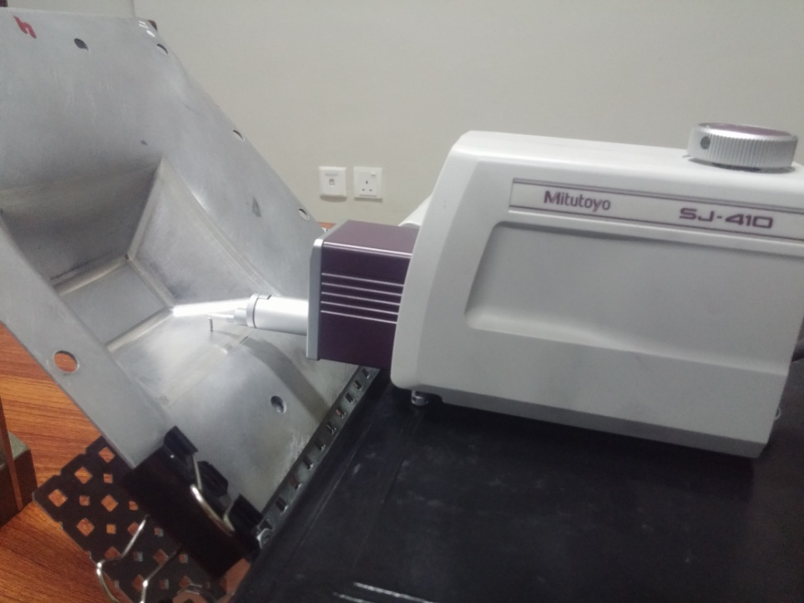

Figure 3.6 Surface roughness testing of sheet formed parts
Geometric accuracy was tested using FeroArm coordinate measurement system (figure 3.8). The part is mounted on a fixture and the profile of the formed part is followed. The cross section middle of the forming side is used for profile generation (figure 3.7). This is due to the maximum deformation at the center of the side as shown in figure 3.7.
Figure 3.8 Measurement regions for geometric accuracy
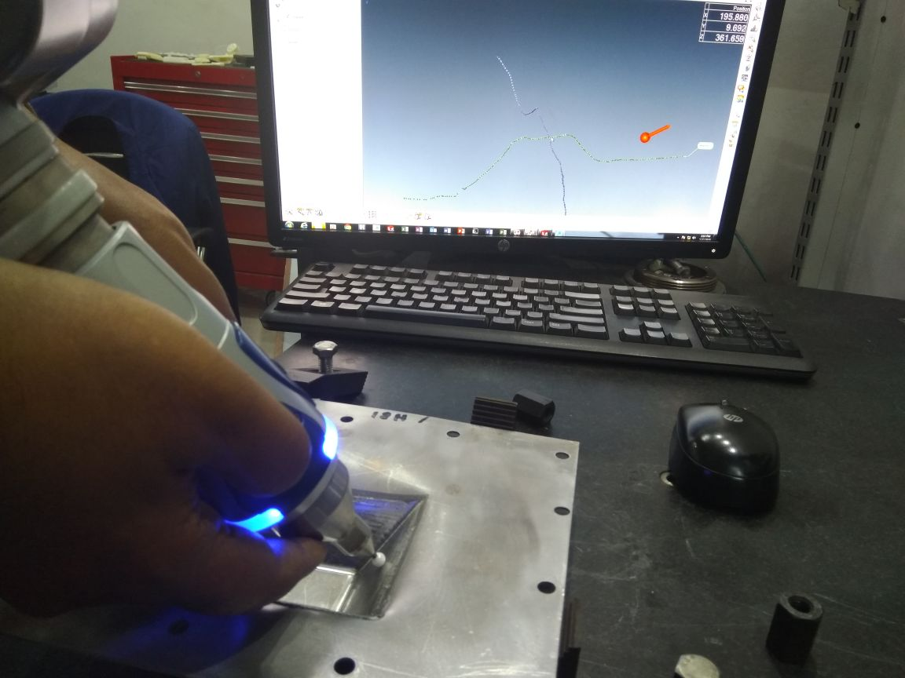

Figure 3.7 Geometric accuracy test of finished part using FARO arm

The generated profile by coordinate measurement system was then analyzed for its geometric deviation. This has been achieved by superimposing the original profile with those obtained from experimentation. The deviation has been observed in the Z plane as is the usual practice in the literature. The part profile along with superimposed desired part profile is shown in figure 3.8

Figure 3.8 actual profile versus desired profile for geometric deviation measurements

Summary
The chapter highlights the research methodology, materials and tooling, process parameters selection, experimental design matrix development, experimental setup used for experimentation, and evaluation of the sample prepared. Materials and tooling involve a brief description of CNC machine setup, sample preparation, back plate arrangement and heating mechanism adopted. Process parameters and their ranges were selected based upon extensive literature review (discussed in Chapter 2). Three processing parameters i.e. spindle speed, step depth and feed rate with four levels were used to develop experimental design matrix using Central Composite Design. The experimental design was developed in Design-Expert 7.0. according to RSM. Experimental procedure along with steps is also described. At the end of this chapter, the procedure for surface roughness measurement and geometric accuracy has been briefly discussed. In the following chapter No.4, analysis of results are shown and discussed with complete design procedure followed.

CHAPTER 4
Results and analysis

Introduction
This chapter presents analysis of the results obtained from surface roughness and geometric deviation tests. The results obtained from surface roughness and geometric deviation tests were analyzed using commercial statistical software. ANOVA is performed on each response and mathematical model is developed in order to predict the responses. The response surface plots have also been discussed along with the percentage improvement results sheet forming under heat and without heat conditions. 3D response surface graph of the developed models are plotted to e depict the effect of various parameters on performance measures.

Development of mathematical models

Mathematical Model for surface roughness

Development of Mathematical model for surface roughness without heat
Regression analysis has been performed to model the performance measures (surface roughness without heat) using commercial statistical software.
Table 4.1 - Fit summary for surface roughness model (without heat)
Source | sum of Squares | Df | Sum of Square | F Value | p value Prob > F
Mean vs Total | 36.2214 | 1 | 36.2214
Linear vs Mean | 1.699435 | 3 | 0.566478 | 5.095682 | 0.0137
2FI vs Linear | 1.408801 | 3 | 0.4696 | 35.00813 | < 0.0001 | Suggested
Quadratic vs 2FI | 0.032106 | 3 | 0.010702 | 0.741595 | 0.5565
Cubic vs Quadratic | 0.075282 | 4 | 0.018821 | 1.874278 | 0.2789 | Aliased
Residual | 0.040166 | 4 | 0.010042
Total | 39.47719 | 18 | 2.193177
The adequacy of the developed models has been tested using analysis of variance (ANOVA) technique. 4.1. for surface roughness. The fit summary for surface roughness suggested linear relationship as best fit models for non heated sheet forming as shown in table 4.1 below:
The ANOVA results highlighted that main effects feed (B) and step depth (C); interaction effects of spindle speed and feed (AB), spindle speed and step depth (AC) and feed and step depth (BC) were the significant model terms associated with surface roughness while considering sheet forming. The ANOVA table comprising of significant terms are shown in Table 4.2 below:
Table 4.2 – Empirical model for surface roughens without heat
Source | Sum of Squares | DOF | Mean Square | F Value | P Value Prob > F
Model | 3.108236012 | 6 | 0.518039335 | 38.61919 | < 0.0001 | Significant
A-Spindle speed | 0.009185204 | 1 | 0.009185204 | 0.6847456 | 0.4255
B-Feed | 0.339574731 | 1 | 0.339574731 | 25.314875 | 0.0004
C-Step depth | 1.350674702 | 1 | 1.350674702 | 100.69112 | < 0.0001
AB | 0.451725125 | 1 | 0.451725125 | 33.675548 | 0.0001
AC | 0.406351125 | 1 | 0.406351125 | 30.292973 | 0.0002
BC | 0.550725125 | 1 | 0.550725125 | 41.055875 | < 0.0001
Residual | 0.147554432 | 11 | 0.013414039
Lack of Fit | 0.127095432 | 8 | 0.015886929 | 2.3295756 | 0.2623 | not significant
Pure Error | 0.020459 | 3 | 0.006819667
Cor Total | 3.255790444 | 17
Std. Dev. | 0.115818994 |  |  | R-Squared |  | 0.954679383
Mean | 1.418555556 |  |  | Adj R-Squared |  | 0.929959046
C.V. % | 8.164572284 |  |  | Pred R-Squared |  | 0.840265873
PRESS | 0.520060846 |  |  | Adeq Precision |  | 23.27197976

The ANOVA results indicate that the model is significant (value of p is less than 0.05). The adequacy measures R², adjusted R² and predicted R² for surface roughness model without heat are close to 1, indicating the adequacy of resulting models. The final empirical model for prediction of under no heat surface roughness during sheet forming is shown in Equation.4.1 below:
Surface Roughness without heat =+7.00847-1.89166E-003 * Spindle speed-0.011532 * Feed-7.69112 * Step depth+2.56545E-006 * Spindle speed * Feed+2.31154E-003* Spindle speed * Step depth+0.012275 * Feed * Step depth
(4.1)

Mathematical model for surface roughness with heat
The fit summary for surface roughness model suggested quadratic relationship as best fit model for heated sheet forming (table 4.3):
Table 4.3 Fit Summary for Surface Roughness Model (under heat)
Source | sum of Squares | df | Sum of Square | F Value | p value Prob > F
Mean vs Total | 23.29714 | 1 | 23.29714
Linear vs Mean | 0.725497 | 3 | 0.241832 | 10.13779 | 0.0008 | Suggested
2FI vs Linear | 0.053099 | 3 | 0.0177 | 0.693204 | 0.5751
Quadratic vs 2FI | 0.158417 | 3 | 0.052806 | 3.450004 | 0.0716 | Suggested
Cubic vs Quadratic | 0.105457 | 4 | 0.026364 | 6.20693 | 0.0524 | Aliased
Residual | 0.01699 | 4 | 0.004248
Total | 24.3566 | 18 | 1.353144
The ANOVA results highlighted that main effects of feed (B) and step depth (C) and quadratic effects of step depth (C²) were the significant model terms associated with surface roughness while considering sheet forming under heat. The ANOVA table comprising of significant terms are shown in Table 4.4.
The results indicate that the model is significant (value of p is less than 0.05). The adequacy measure R2, adjusted R2 and predicted R2 for surface roughness during sheet forming under heated condition are close to 1, indicating the adequacy of resulting models. The final empirical model for prediction of under no heat surface roughness during sheet forming is shown in Equation.4.2 below:

Table 4.4 - ANOVA for Surface Roughness Model (under heat)
Source | Sum of Squares | DOF | Mean Square | F Value | P Value Prob > F
Model | 0.937012408 | 9 | 0.10411249 | 6.8020931 | 0.0064 | Significant
A-Spindle speed | 0.052942344 | 1 | 0.052942344 | 3.458939 | 0.1000
B-Feed | 0.433861651 | 1 | 0.433861651 | 28.345949 | 0.0007
C-Step depth | 0.238692668 | 1 | 0.238692668 | 15.594764 | 0.0042
AB | 0.0406125 | 1 | 0.0406125 | 2.6533801 | 0.1420
AC | 0.001682 | 1 | 0.001682 | 0.1098919 | 0.7488
BC | 0.0108045 | 1 | 0.0108045 | 0.705902 | 0.4252
A^2 | 3.80377E-05 | 1 | 3.80377E-05 | 0.0024852 | 0.9615
B^2 | 0.0568364 | 1 | 0.0568364 | 3.7133535 | 0.0901
C^2 | 0.117061381 | 1 | 0.117061381 | 7.6480969 | 0.0245
Residual | 0.122447592 | 8 | 0.015305949
Lack of Fit | 0.110193592 | 5 | 0.022038718 | 5.3954754 | 0.0980 | not significant
Pure Error | 0.012254 | 3 | 0.004084667
Cor Total | 1.05946 | 17
Std. Dev. | 0.123717214 |  |  | R-Squared |  | 0.884424525
Mean | 1.137666667 |  |  | Adj R-Squared |  | 0.754402117
C.V. % | 10.87464524 |  |  | Pred R-Squared |  | 0.86005479
PRESS | 0.968340635 |  |  | Adeq Precision |  | 8.083520792

Surface Roughenss Under Heat =+1.61415+4.74848E-004 * Spindle speed-2.87599E-003* Feed-2.89417 * Step depth-7.69231E-007 * Spindle speed * Feed-1.48718E-004 * Spindle speed * Step depth+1.71930E-003 * Feed * Step depth-4.10440E-009 * Spindle speed2 +3.30105E-006 * Feed2+4.27556 * Step depth2
(4.2)

Mathematical model for dimensional accuracy
The dimensional accuracy has been observed for (i) forming with back plate and (ii) without back plate for both the temperature conditions (heated and No-heat).

Mathematical model for dimensional accuracy with support under No-heat condition
The fit summary for dimensional accuracy (with support) under No-heat condition suggested quadratic relationship as the best fit model (table 4.5) :
Table 4.5 - Fit summary for dimensional Accuracy model with support (No-Heat condition)
 | Sum of |  | Mean | F | p-value
Source | Squares | Df | Square | Value | Prob> F
Mean vs Total | 818.816 | 1 | 818.816
Linear vs Mean | 0.27767 | 3 | 0.092557 | 0.374309 | 0.7727
2FI vs Linear | 1.916338 | 3 | 0.638779 | 4.070557 | 0.0305
Quadratic vs 2FI | 1.951208 | 3 | 0.650403 | 73.21097 | < 0.0001 | Suggested
Cubic vs Quadratic | 0.06903 | 4 | 0.017257 | 5.22692 | 0.0369
Residual | 0.01981 | 6 | 0.003302
Total | 823.0501 | 20 | 41.15251
ANOVA results for formed Al 2291 sheet revealed that the main effects of spindle speed (A), and step depth (C), interaction effect of speed x feed(AB), Speed x step depth (AC), Feed x step depth (BC and quadratic effects of spindle speed (A2), feed rate (B2) and step depth (C2) are significant model terms. The ANOVA table comprising of significant model terms along with adequacy measure R2, adjusted R2 and predicted R2 has been provided in Table 4.6. With p value less than 0.05, the models are significant. The final empirical model for accuracy with support (No-heat condition) is given in Equation. 4.3:
Accuracy with support (No-heat)=-1.95002+3.43929E-003* Spindle speed+0.011591* Feed Rate+15.73836 * Step Depth+1.71390E-006 * Spindle Speed * Feed Rate-2.73077E-003 * Spindle Speed * Step Depth-0.017719 * Feed Rate * Step Depth-7.38144E-007 * Spindle Speed2-1.07442E-005 * Feed Rate2-4.43262 * Step Depth2
4.3
Table 4.6 ANOVA for surface dimensional Accuracy model for with back plate (No-heat condition)
 | Sum of |  | Mean | F | p-value
Source | Squares | Df | Square | Value | Prob> F
Model | 4.145216 | 9 | 0.46058 | 51.844 | < 0.0001 | Significant
A-Spindle Speed | 0.137431 | 1 | 0.137431 | 15.46954 | 0.0028
B-Feed Rate | 0.016839 | 1 | 0.016839 | 1.895414 | 0.1986
C-Step Depth | 0.123401 | 1 | 0.123401 | 13.89033 | 0.0039
AB | 0.201613 | 1 | 0.201613 | 22.69402 | 0.0008
AC | 0.567113 | 1 | 0.567113 | 63.83563 | < 0.0001
BC | 1.147613 | 1 | 1.147613 | 129.1782 | < 0.0001
A^2 | 1.401647 | 1 | 1.401647 | 157.7729 | < 0.0001
B^2 | 0.685977 | 1 | 0.685977 | 77.21536 | < 0.0001
C^2 | 0.143347 | 1 | 0.143347 | 16.13548 | 0.0025
Residual | 0.088839 | 10 | 0.008884
Lack of Fit | 0.069156 | 5 | 0.013831 | 3.513438 | 0.0971 | not significant
Pure Error | 0.019683 | 5 | 0.003937
Cor Total | 4.234055 | 19
Std. Dev. | 0.094255 |  |  | R-Squared |  | 0.979018
Mean | 6.3985 |  |  | Adj R-Squared |  | 0.960134
C.V. % | 1.473075 |  |  | Pred R-Squared |  | 0.869189
PRESS | 0.553863 |  |  | Adeq Precision |  | 23.41938

4.3.3.2 Mathematical model for dimensional accuracy without support (No-heat)
The fit summary for dimensional accuracy without support (under No-heat) suggested quadratic relation as the best fit model as shown in table 4.7:
ANOVA results for formed Al 2219 sheet revealed that the main effects of spindle speed (A), and step depth (C) , interaction effect of speed x feed(AB), Speed x step depth (AC), Feed x step depth (BC) and quadratic effects of spindle speed (A2), feed rate (B2) and step depth (C2) are significant model terms.

Table 4.7 – Fit Summary for dimensional Accuracy model without back plate (No- heat)
 | Sum of |  | Mean | F | p-value
Source | Squares | Df | Square | Value | Prob> F
Mean vs Total | 1463.076 | 1 | 1463.076
Linear vs Mean | 0.085839 | 3 | 0.028613 | 0.382212 | 0.7672
2FI vs Linear | 0.2417 | 3 | 0.080567 | 1.095479 | 0.3859
Quadratic vs 2FI | 0.926008 | 3 | 0.308669 | 102.6376 | < 0.0001 | Suggested
Cubic vs Quadratic | 0.016961 | 4 | 0.00424 | 1.940295 | 0.2231 | Aliased
Residual | 0.013112 | 6 | 0.002185
Total | 1464.36 | 20 | 73.21799
Table 4.8 ANOVA for surface dimensional Accuracy model without back plate (No-heat)
Source | Squares | df | Square | Value | Prob> F
Model | 1.253546 | 9 | 0.139283 | 46.31387 | < 0.0001 | Significant
A-Spindle Speed | 0.017679 | 1 | 0.017679 | 5.878473 | 0.0358
B-Feed Rate | 0.014176 | 1 | 0.014176 | 4.713764 | 0.0551
C-Step Depth | 0.053984 | 1 | 0.053984 | 17.95055 | 0.0017
AB | 0.03645 | 1 | 0.03645 | 12.12023 | 0.0059
AC | 0.14045 | 1 | 0.14045 | 46.70194 | < 0.0001
BC | 0.0648 | 1 | 0.0648 | 21.54707 | 0.0009
A^2 | 0.06571 | 1 | 0.06571 | 21.84952 | 0.0009
B^2 | 0.074976 | 1 | 0.074976 | 24.93067 | 0.0005
C^2 | 0.758782 | 1 | 0.758782 | 252.3077 | < 0.0001
Residual | 0.030074 | 10 | 0.003007
Lack of Fit | 0.01774 | 5 | 0.003548 | 1.438408 | 0.3498 | not significant
Pure Error | 0.012333 | 5 | 0.002467
Cor Total | 1.28362 | 19
Std. Dev. | 0.054839 |  |  | R-Squared |  | 0.976571
Mean | 8.553 |  |  | Adj R-Squared |  | 0.955485
C.V. % | 0.641173 |  |  | Pred R-Squared |  | 0.880661
PRESS | 0.153186 |  |  | Adeq Precision |  | 25.94933

The ANOVA table comprising of significant model terms along with adequacy measure R2, adjusted R2 and predicted R2 has been provided in Table 4.8. With p value less than 0.05, the models are significant.
Equation for accuracy without support (No-heat)= +5.95211+1.97740E-004 * Spindle Speed+2.44486E-003 * Feed Rate+9.84689 * Step Depth-7.28745E-007 * Spindle Speed * Feed Rate-1.35897E-003 * Spindle Speed * Step Down+4.21053E-003 * Feed Rate * Step Depth+1.59822E-007 * Spindle Speed2-3.55205E-006 * Feed Rate2-10.19823 * Step Depth2
(4.4)

Mathematical model for dimensional accuracy with back plate(under heat)
For The fit summary for model of dimensional accuracy with support under heat suggested quadratic relation as the best fit model as shown in table 4.9:
Table 4.9 - Fit summary for dimensional Accuracy model with back plate (with heat)
 | Sum of |  | Mean | F | p-value
Source | Squares | df | Square | Value | Prob> F
Mean vs Total | 412.1412 | 1 | 412.1412
Linear vs Mean | 2.454065 | 3 | 0.818022 | 1.808975 | 0.1861
2FI vs Linear | 1.842638 | 3 | 0.614213 | 1.480691 | 0.2658
Quadratic vs 2FI | 5.191093 | 3 | 1.730364 | 85.87429 | < 0.0001 | Suggested
Cubic vs Quadratic | 0.132185 | 4 | 0.033046 | 2.860541 | 0.1208
Residual | 0.069315 | 6 | 0.011552
Total | 421.8305 | 20 | 21.09153

ANOVA results for formed Al sheet revealed that the main effects of spindle speed (A), feed (B) and step depth (C), combined effects of spindle speed and feed(AB), feed and step depth(BC), spindle speed and step depth(AC) including quadratic effects of spindle speed (A2), feed rate (B2) and step depth (C2) are significant model terms. The ANOVA table comprising of significant model terms along with adequacy measure R2, adjusted R2 and predicted R2 has been provided in Table 4.10. With p value less than 0.05, the models are significant.
Table 4.10 ANOVA for surface dimensional Accuracy model for two sides with back plate support (with heat)
 | Sum of |  | Mean | F | p-value
Source | Squares | df | Square | Value | Prob> F
Model | 9.487795 | 9 | 1.054199 | 52.31767 | < 0.0001 | significant
A-Spindle Speed | 2.128706 | 1 | 2.128706 | 105.6431 | < 0.0001
B-Feed Rate | 0.159207 | 1 | 0.159207 | 7.901086 | 0.0184
C-Step Depth | 0.166152 | 1 | 0.166152 | 8.245778 | 0.0166
AB | 0.148513 | 1 | 0.148513 | 7.370358 | 0.0218
AC | 1.209013 | 1 | 1.209013 | 60.00071 | < 0.0001
BC | 0.485113 | 1 | 0.485113 | 24.0751 | 0.0006
A^2 | 2.231725 | 1 | 2.231725 | 110.7557 | < 0.0001
B^2 | 0.386247 | 1 | 0.386247 | 19.1686 | 0.0014
C^2 | 3.346841 | 1 | 3.346841 | 166.0966 | < 0.0001
Residual | 0.2015 | 10 | 0.02015
Lack of Fit | 0.164766 | 5 | 0.032953 | 4.485473 | 0.0626 | not significant
Pure Error | 0.036733 | 5 | 0.007347
Cor Total | 9.689295 | 19
Std. Dev. | 0.141951 |  |  | R-Squared |  | 0.979204
Mean | 4.5395 |  |  | Adj R-Squared |  | 0.960487
C.V. % | 3.127009 |  |  | Pred R-Squared |  | 0.863579
PRESS | 1.321824 |  |  | Adeq Precision |  | 22.67067
The final empirical model for Spring back for two sides with support with heat given in Equation. 4.5 below:
Accuracy with support under heat condition==+11.24537-2.44023E-003* Spindle Speed-7.01667E-003* Feed Rate-13.81927* Step Depth-1.47099E-006 * Spindle Speed * Feed Rate-3.98718E-003* Spindle Speed * Step Depth+0.011520 * Feed Rate * Step Depth+9.31413E-007 * Spindle Speed2+8.06216E-006 * Feed Rate2+21.41823 * Step Depth2
(4.5)

Mathematical model for dimensional accuracy under heat without back plate
The fit summary for dimensional accuracy with support under heat suggested quadratic relation as the best fit model as shownin table 4.11.
Table 4.11 Fit Summary for dimensional Accuracy model for two sides without back plate support (with heat)
 | Sum of |  | Mean | F | p-value
Source | Squares | df | Square | Value | Prob> F | Source
Mean vs Total | 1320.963 | 1 | 1320.963 |  |  | Mean vs Total
Linear vs Mean | 2.216427 | 3 | 0.738809 | 1.871056 | 0.1752 | Linear vs Mean
2FI vs Linear | 1.51245 | 3 | 0.50415 | 1.363888 | 0.2973 | 2FI vs Linear
Quadratic vs 2FI | 4.61705 | 3 | 1.539017 | 81.73538 | < 0.0001 | Quadratic vs 2FI
Cubic vs Quadratic | 0.155273 | 4 | 0.038818 | 7.053612 | 0.0187 | Cubic vs Quadratic
Residual | 0.03302 | 6 | 0.005503 |  |  | Residual
Total | 1329.497 | 20 | 66.47484 |  |  | Total
 | Sum of |  | Mean | F | p-value

ANOVA results for formed Al sheet revealed that the main effects of spindle speed (A), and step depth (C), combined effects of spindle speed and feed rate (AB) , feed rate and step depth(BC) with inclusion of quadratic effects of spindle speed (A2), feed rate (B2) and step depth (C2) are significant model terms. The ANOVA table comprising of significant model terms along with adequacy measure R2, adjusted R2 and predicted R2 has been provided in Table 4.12. With p value less than 0.05, the models are significant.

Table 4.12 ANOVA for surface dimensional Accuracy model for two sides without back plate support (with heat)
Source | Squares | Df | Square | Value | Prob> F
Model | 8.345927 | 9 | 0.927325 | 49.24916 | < 0.0001 | significant
A-Spindle Speed | 1.161467 | 1 | 1.161467 | 61.68418 | < 0.0001
B-Feed Rate | 0.003692 | 1 | 0.003692 | 0.196082 | 0.6673
C-Step Depth | 1.051268 | 1 | 1.051268 | 55.8316 | < 0.0001
AB | 0.41405 | 1 | 0.41405 | 21.98971 | 0.0009
AC | 0.0032 | 1 | 0.0032 | 0.169948 | 0.6889
BC | 1.0952 | 1 | 1.0952 | 58.16479 | < 0.0001
A^2 | 0.601157 | 1 | 0.601157 | 31.92673 | 0.0002
B^2 | 2.170523 | 1 | 2.170523 | 115.274 | < 0.0001
C^2 | 2.627343 | 1 | 2.627343 | 139.5351 | < 0.0001
Residual | 0.188293 | 10 | 0.018829
Lack of Fit | 0.155559 | 5 | 0.031112 | 4.75232 | 0.0561 | not significant
Pure Error | 0.032733 | 5 | 0.006547
Cor Total | 8.53422 | 19
Std. Dev. | 0.13722 |  |  | R-Squared |  | 0.977937
Mean | 8.127 |  |  | Adj R-Squared |  | 0.95808
C.V. % | 1.688443 |  |  | Pred R-Squared |  | 0.855678
PRESS | 1.231679 |  |  | Adeq Precision |  | 17.80216

Accuracy without support (with heat) = +5.49184+7.48022E-004 * Spindle Speed+2.68268E-003 * Feed Rate+10.67802 * Step Depth+2.45614E-006 * Spindle Speed * Feed Rate-2.05128E-004 * Spindle Speed * Step Depth+0.017310* Feed Rate * Step Depth-4.83410E-007* Spindle Speed2-1.91118E-005* Feed Rate2-18.97686 * Step Depth
(4.6)

3D response surface plots
The effects of process parameters on surface roughness and dimensional accuracy for both heated and non heated conditions have been analyzed using 3D response surface plots (Figures 4.1 – 4.18). It is pertinent to note that these figures represent the effects of two process parameters at the center level of all other process parameters.

Response surface plot of surface roughness without heat
The effects of spindle speed and feed on surface roughness (without heat) have been shown in figure 4. It is evident that surface roughens increases with the decrease in seed at low level of feed. At high level of speed, reverse is true. Furthermore is more effected by the variation in spindle speed at higher levels of feed. By increasing feed surface roughens decreases at low level of speed and vice versa.
Figure 4.1: Effect of spindle speed and feed on surface roughness (without heat)
The effects of spindle speed and step depth on surface roughness (without heat) have been shown in figure 4.2. It is evident that increase in surface resistance is due to increase in step depth and it decreases with increase in spindle speed. The surface roughness is more sensitive to variation in step depth as compared to spindle speed.
Fig 4.2: Effect of spindle speed and step depth on surface roughness (without heat)
The effects of feed and step depth on surface roughness (without heat) have been demonstrated in Figure 4.3. It is evident that by increasing strep depth, surface roughens decreases. . The surface roughness is more sensitive to variation in step depth as compared to feed rate.
Fig 4.3 Effect of step depth and feed on surface roughness (without heat)

Effect of process parameters on surface roughness under heat
The effects of spindle speed and feed on surface roughness (under heat) are shown in figure 4.4. It is evident that surface roughness increases with increase in speed while it decreases with increase in feed rate. Furthermore, the surface roughness is more sensitive to variation in feed rate as compared to spindle speed.
Figure 4.4: Effect of spindle speed and feed on surface roughness (under heat)
The effects of spindle speed and step depth on surface roughness (without heat) are shown in fig 4.2. It is evident that increase in surface roughness is due to increase in both step depth and spindle speed. By increasing step depth upto a certain level the effect of step depth on surface roughness is less. Further increase in step depth has results in significant increase in surface roughness.

Fig 4.5: Effect of spindle speed and step depth on surface roughness (under heat)
Figure 4.6 presents the effects of feed and step depth on surface roughness (with heat). It is evident that with increase of step depth, surface roughness increases. Furthermore, surface roughness decreases with increase in feed. It is worthy to mention that effect of step depth on surface roughness is more than feed.
Fig 4.6 Effect of step depth and feed on surface roughness (without heat)

Effect of process parameters on Dimensional Accuracy with back plate under No heat condition
The effects of spindle speed and feed on geometric accuracy with back plate (No-heat) have been shown in figure 4.7. From the figure, it is clearly evident that with increase in both feed and spindle speed, geometric error initially increases upto a certain level. Further increase in both these parameters beyond these level results in decrease geometric deviation. Furthermore, lower geometric deviation can be achieved at the highest level of spindle speed.
Figure 4.7 Effect of spindle speed and feed on geometric accuracy with back plate support (without heat)
The effects of spindle speed and step depth on geometric accuracy with back plate (without heat) have been shown in figure 4.8. It can be observed from the figure that with increase in both spindle speed and step depth upto a certain level, the geometric deviation increases. Further increase in these process parameters has minimal effect on geometric deviation. Furthermore, the geometric deviation is minimum at lowest level of spindle speed and step depth.
Figure 4.8 Effect of step depth and spindle speed on dimensional accuracy with back plate support (without heat)
The effects of feed and step depth on geometric accuracy with back plate (No-heat) have been shown in figure 4.9. It is evident that effect of feed and step down is different at different levels of step down and feed rate. At low level of step down, geometric deviation decreases with increase in feed. At higher level of step depth, on the other hand, geometric deviation increases with increase in feed. The effect of feed on geometric deviation is similar to the effect of feed rate on geometric deviation.
Figure 4.9 Effect of step depth and feed on dimensional accuracy with back plate support (without heat)

Effect of process parameters on Dimensional Accuracy without back plate (no-heat)
The effects of spindle speed and feed on geometric accuracy without back plate have been provided in figure 4.10. it is evident that with increase in both feed and spindle speed, geometric error increases. The only difference is with feed increase geometric error first increases and after a certain stage its increase is negligible. While Response of geometric error for spindle speed is less with increase in spindle speed initially but with further increase the effect of spindle speed increases gradually.
Figure 4.10 Effect of spindle speed and feed on dimensional accuracy without back plate support (without heat)
The effects of spindle speed and step depth on geometric accuracy without back plate (no-heat) have been shown in figure 4.11. It is evident that with increase in spindle speed geometric error increases. While, with increase in step depth geometric error is at rise very less initially and then it effect become comparatively more significant after a specific level.
Figure 4.11 Effect of spindle speed and step depth on dimensional accuracy without back plate support (without heat)
The effects of feed and step depth on geometric accuracy without back plate support (No-heat) have been shown in figure 4.12. It can clearly be observed that with increase in both spindle feed and step depth, geometric error first increases and then decreases. Furthermore, response for Geometric error is more pronounced step depth then feed.
Figure 4.12 Effect of step depth and feed on dimensional accuracy without back plate support (without heat)

Effects of process parameters on Dimensional Accuracy with with back plate under heat condition
The effects of spindle speed and feed on geometric accuracy with back plate (with heat) have been shown in figure 4.13. It is evident that feed has no significant effect on geometric deviation. While an increase in spindle speed, geometric error decreases gradually upto a certain level. With further incrase in spindle speed, change in geometric error remain almost negligible.
Figure 4.13 Effect of spindle speed and feed on dimensional accuracy with back plate support (with heat)
The effects of spindle speed and step depth on geometric accuracy with back plate under heated condition have been shown in figure 4.14. It is evident from the figure that with increase in spindle speed and step depth geometric error decreases upto a level and then it increases. Response of geometric error is almost same for both input parameters.
Figure 4.14 Effect of spindle speed and step depth on dimensional accuracy with back plate support (with heat)
Figure 4.15 Effect of step depth and feed on dimensional accuracy with back plate support (with heat)
The effects of feed and step depth on geometric accuracy with back plate support (with heat) have been shown in figure 4.15. It can clearly be established that with increase in both spindle feed and step depth geometric error first decreases and then increases. Further, response for Geometric error is more pronounced for feed then step depth.

Effect of process parameters on Dimensional Accuracy without back plate (with heat)
The effects of spindle speed and feed on geometric accuracy without back plate support (with heat) have been shown in figure 4.16. It is evident that with increase in feed and geometric error increases upto a certain level and then decreases. Furthermore, more decreased in geometric deviation has been observed at higher level of feed. Geometric deviation increases with increase in spindle speed.
Figure 4.16 Effect of spindle speed and feed on dimensional accuracy without back plate support (with heat)
The effects of spindle speed and step depth on geometric accuracy without back plate (with heat) have been shown in figure 4.17. It is evident that with increase in spindle speed and step depth geometric error increases upto a level and then it reduces. Less geometric deviation can be achieved at highest level of spindle speed.
Figure 4.17 Effect of spindle speed and step depth on dimensional accuracy without back plate support (with heat)
The effects of feed and step depth on geometric accuracy without back plate support (with heat) have been shown in figure 4.18. It is evident that with increase in both spindle feed and step depth geometric error first increases and then decreases. Furthermore, lowest geometric deviation has been observed for highest feed rate.
Figure 4.18 Effect of step depth and feed on dimensional accuracy without back plate support (with heat)

Validation
Six Confirmation experiments were conducted to validate the models experimentally under heat and no heat conditions. These value of process parameters for these experiments were randomly chosen within design space in such a way that these were different from those use for the empirical model development. The results of validation experiments depict the difference between actual and predicted values. Percentage error was calculated using equation 4.6 and has been provided in Table 4.13.
$$Percentage Error=\left|\frac{Actual value-Predicted Value}{Actual Value}\right|×100$$
(4.6)
It is clearly evident from the table that percentage error is less than 7%, which validates the empirical model developed for the prediction. It can be established from validation experiments that the developed empirical models have the capability to predict surface roughness and accuracy accurately with minor deviation.
Table 4.13- Deviation of results shown for validation of Empirical Model
Experimental Condition | Process parameters |  |  | Surface Roughness (µm) |  |  | Dimensional Deviation (mm)
 |  |  |  | With heat |  |  | With support plate |  |  | Without support plate
 | Spindle speed | Feed | Step depth | Predicted | Actual | Error | Predicted | Actual | Error | Predicted | Actual | Error
With heat | 2350 | 350 | 0.375 | 1.103 | 1.176 | 6.2% | 3.81 | 3.64 | 4.7% | 8.62 | 8.9 | 3.1%
 | 1630 | 290 | 0.425 | 1.164 | 1.213 | 4.0% | 4.29 | 4.05 | 5.9% | 8.86 | 9.2 | 3.7%
 | 1925 | 420 | 0.36 | 0.800 | 0.775 | 3.2% | 4.11 | 3.92 | 4.8% | 8.74 | 8.69 | 0.6%
Without heat | 1830 | 490 | 0.29 | 0.936 | 0.993 | 5.7% | 6.72 | 7.2 | 6.7% | 8.42 | 7.9 | 6.6%
 | 1435 | 295 | 0.26 | 1.647 | 1.545 | 6.6% | 6.07 | 5.98 | 1.5% | 8.35 | 8.01 | 4.2%
 | 2540 | 350 | 0.47 | 1.315 | 1.3 | 1.2% | 6.50 | 6.4 | 1.6% | 8.7 | 8.93 | 2.6%

Comparison of Results

Comparison of Surface roughness under heat and no-heat conditions
Surface roughness for both temperature conditions has been compared using comparison chart as provided n in figure 4.19. It is clearly evident from the figure that surface roughness achieved for ISF under heat condition is better than no-heat condition for most of the experimental conditions. For runs numbers 3, 5 and 6 only (Percentage with negative sign), the surface roughness is better in case of no-heat condition. It is also evident that the heating of workpiece during ISF reduce the surface roughness ranging from 6%~48%. Thus it can be established that heating condition results in better surface roughness.
Figure 4.19- Comparison of surface roughness under heat and under no heat

Comparison of Geometric deviation under heat and under no Heat
The effect of heat on Geometric deviation was investigated under two cases; (i) back plate and (ii) without back plate. The comparison in the form of graphs has been provided in figure4.20 and figure 4.21 for both these cases.
As mentioned in figure 4.20, It is clearly evident that geometric deviation for ISF under heat condition is better than no-heat condition for most of the experimental conditions. For runs numbers 3, 4,13, 14 and 15 only (Percentage with negative sign), the geometric deviation is more in case of work piece under heat condition. It is also evident that the heating of workpiece during ISF reduce the geometric deviation ranging from 2.1%~19.1%. Thus, it can be established that heating condition results in better geometric accuracy once there is no back plate support provided.

Figure 4.20- Comparison of geometric deviation without back plate support

Figure 4.21- Comparison of geometric deviation with back plate support
The comparison shown in figure 4.21 clearly depicts that geometric deviation for ISF under heat condition with back plate is better than no-heat condition for almost all of the experimental runs. For run number 12 only (Percentage with negative sign), the geometric deviation is more in case of work piece under heat condition. It is also evident that the heating of workpiece during ISF reduce the geometric deviation ranging from 12.2% to 81.5% as compared to 2.1%~19.1% which was reduction of geometric deviation under same conditions but with no support plate. Thus it can be established that heating condition with back plate support results in superior geometric accuracy.

Summary
This chapter covers the analysis of results obtained from two tests namely surface roughness test and geometric deviation. The plots obtained from geometric deviation were extruded in PRO- E and the results of both tests were analyzed. Mathematical model for each response was developed to predict the response value for a given set of parameters. ANOVA was performed to find the significance of the model and to identify the significant parameters for each response. The combined effect of two parameters on each response is discussed using 3D graphs. The comparison has been provided to evaluate the effectivity of ISF under heated conditions for both dimensional accuracy and surface roughness.

CHAPTER 5

Conclusions and Future Recommendations

Introduction
In this research the aim was to improve performance measures involves in incremental sheet forming including surface roughness and geometric deviation. This has been achieved by performing and evaluating incremental sheet forming at two conditions i.e, at elevated temperature and at room temperature. The comparison of both the conditions has been achieved by performing experiments and developing empirical relationships as per central composite design. The developed empirical models were validated by six additional experiments and the percentage error was found less than 7% for instances which shows that the developed models can be used for prediction. Furthermore, the effects of heat on performance measures have also been compared on two different conditions of incremental sheet forming i.e. support and without support. The conclusions of this research have been presented in detail in the following section

Conclusions
Conclusions drawn from results for both the responses including surface roughness and accuracy (geometric deviation) have been provided below:
5.2.1 Surface Roughness
- Most significant factor affecting surface roughness is step depth followed by spindle speed and lastly among three parameters being discussed is feed.
- Surface roughness increases significantly on increase in step depth.
- The comparison of surface roughness under heat and no-heat conditions reflects that surface roughness achieved for ISF under heat condition is better than no-heat condition for most of the experimental conditions.
- The reduction due to heating of workpiece during ISF reduces the surface roughness ranging from 6%~48%. This high percentage reduction clearly demonstrates the superiority of ISF under heated condition.
- Minimum surface roughness achieved is 0.65µm- under heat condition.

5.2.2 Geometric Accuracy
- Most significant factor affecting geometric accuracy is step depth followed by spindle speed and lastly among three parameters being discussed is feed.
- On increase in step depth, Geometric deviation first decreases and then increases.
- The comparison of Geometric deviation under heat and no heat condition reflects that geometric accuracy is better for ISF under heat condition better than no-heat condition for majority of experimental conditions.
- Once comparison is drawn for geometric accuracy with and without back plate under heat condition, superior geometric accuracy was achieved for most of the experimental conditions employing back plate under heat.
- Minimum value of geometric deviation achieved is 3.79% under heat condition with back plate.

Future Recommendations
The future work may include the following
- More investigation on effect of heating on formability which may include maximum forming angle and forming behavior
- The principles developed in the current research can be used for the investigation of sandwiched panels which is currently not feasible with the current state of the art.
- Finding new ways to avoid geometrical deviation other than back plate.

References

[1] V. Gulati, A. Aryal, P. Katyal, and A. Goswami, "Process parameters optimization in single point incremental forming," Journal of The Institution of Engineers (India): Series C, vol. 97, pp. 185-193, 2016.
[2] P. Gabriel and B. Adrian, "Developing an experimental case in aluminium foils 1100 to determine the maximum angle of formability in a piece by Dieless-SPIF process," in IOP Conference Series: Materials Science and Engineering, 2014, p. 012027.
[3] J. Jeswiet, F. Micari, G. Hirt, A. Bramley, J. Duflou, and J. Allwood, "Asymmetric single point incremental forming of sheet metal," CIRP Annals-Manufacturing Technology, vol. 54, pp. 88-114, 2005.
[4] M. Azaouzi and N. Lebaal, "Tool path optimization for single point incremental sheet forming using response surface method," Simulation Modelling Practice and Theory, vol. 24, pp. 49-58, 2012.
[5] H. Khalatbari, A. Iqbal, X. Shi, L. Gao, G. Hussain, and M. Hashemipour, "High-speed incremental forming process: A trade-off between formability and time efficiency," Materials and Manufacturing Processes, vol. 30, pp. 1354-1363, 2015.
[6] G. Centeno, M. Silva, V. Cristino, C. Vallellano, and P. Martins, "Hole-flanging by incremental sheet forming," International Journal of Machine Tools and Manufacture, vol. 59, pp. 46-54, 2012.
[7] G. Ambrogio, C. Ciancio, L. Filice, and F. Gagliardi, "Innovative metamodelling-based process design for manufacturing: An application to Incremental Sheet Forming," International Journal of Material Forming, vol. 10, pp. 279-286, 2017.
[8] D. Leach, A. Green, and A. Bramley, "A new incremental sheet forming process for small batch and prototype parts," in 9th International Conference on Sheet Metal, Leuven, 2001, pp. 211-218.
[9] F. Micari, G. Ambrogio, and L. Filice, "Shape and dimensional accuracy in single point incremental forming: state of the art and future trends," Journal of Materials Processing Technology, vol. 191, pp. 390-395, 2007.
[10] H. Amino, Y. Lu, T. Maki, S. Osawa, and K. Fukuda, "Dieless NC forming, prototype of automotive service parts," in Proceedings of the 2nd International Conference on Rapid Prototyping and Manufacturing (ICRPM), Beijing, 2002.
[11] T. Kim and D. Yang, "Improvement of formability for the incremental sheet metal forming process," International Journal of Mechanical Sciences, vol. 42, pp. 1271-1286, 2000.
[12] M. Bambach, Process Strategies and Modelling Approaches for Asymmetric Incremental Sheet Forming: D 82 (Diss. RWTH Aachen), 2008.
[13] Z. Liu, S. Liu, Y. Li, and P. A. Meehan, "Modeling and optimization of surface roughness in incremental sheet forming using a multi-objective function," Materials and Manufacturing Processes, vol. 29, pp. 808-818, 2014.
[14] G. Hirt, J. Ames, M. Bambach, and R. Kopp, "Forming strategies and process modelling for CNC incremental sheet forming," CIRP Annals-Manufacturing Technology, vol. 53, pp. 203-206, 2004.
[15] G. Hirt, J. Ames, and M. Bambach, "A New Forming Strategy to Realise Parts Designed for Deep‐drawing by Incremental CNC Sheet Forming," Steel research international, vol. 76, pp. 160-166, 2005.
[16] P. Chinnaiyan and A. Jeevanantham, "Multi-objective optimization of single point incremental sheet forming of AA5052 using Taguchi based grey relational analysis coupled with principal component analysis," International journal of precision engineering and manufacturing, vol. 15, pp. 2309-2316, 2014.
[17] Z. Liu, Y. Li, and P. A. Meehan, "Vertical wall formation and material flow control for incremental sheet forming by revisiting multistage deformation path strategies," Materials and manufacturing processes, vol. 28, pp. 562-571, 2013.
[18] P. Uttarwar, S. Raini, and D. Malwad, "Optimization of process parameter on Surface Roughness (Ra) and Wall Thickness on SPIF using Taguchi method," International Research Journal of Engineering and Technology, vol. 2, 2015.
[19] G. Hussain, H. Khan, L. Gao, and N. Hayat, "Guidelines for tool-size selection for single-point incremental forming of an aerospace alloy," Materials and Manufacturing Processes, vol. 28, pp. 324-329, 2013.
[20] M. Rauch, J.-Y. Hascoet, J.-C. Hamann, and Y. Plenel, "Tool path programming optimization for incremental sheet forming applications," Computer-Aided Design, vol. 41, pp. 877-885, 2009.
[21] C. Radu, "Effects of Process Parameters on the Quality of Parts Processed by Single Point Incremental Forming," Int. J. Mod. Manuf. Technol, vol. 3, pp. 91-96, 2011.
[22] J. R. Patel, K. S. Samvatsar, H. P. Prajapati, and S. S. Rangrej, "Optimization of Process Parameters for Reducing Surface Roughness Produced During Single Point Incremental Forming Process," International Journal on Recent Technologies in Mechanical and Electrical Engineering, vol. 2, pp. 019-023, 2015.
[23] W. K. Sarraji, J. Hussain, and W.-X. Ren, "Experimental investigations on forming time in negative incremental sheet metal forming process," Materials and Manufacturing Processes, vol. 27, pp. 499-506, 2012.
[24] H. Mohammadi, M. Sharififar, and A. A. Ataee, "Numerical and Experimental Analysis and Optimization of Process Parameters of AA1050 Incremental Sheet Forming," Journal of Computational Applied Mechanics, vol. 45, pp. 35-45, 2014.
[25] Y. Li, Z. Liu, W. Daniel, and P. Meehan, "Simulation and experimental observations of effect of different contact interfaces on the incremental sheet forming process," Materials and Manufacturing Processes, vol. 29, pp. 121-128, 2014.
[26] S. Kurra, S. P. Regalla, and R. Pérez-Santiago, "Study on influence of process parameters in incremental forming using finite element simulations and Taguchi orthogonal array," Advances in Materials and Processing Technologies, vol. 1, pp. 201-209, 2015.
[27] M. Durante, A. Formisano, and A. Langella, "Comparison between analytical and experimental roughness values of components created by incremental forming," Journal of Materials Processing Technology, vol. 210, pp. 1934-1941, 2010.
[28] A. Daleffe, L. Schaeffer, D. Fritzen, and J. Castelan, "Analysis of the incremental forming of titanium F67 grade 2 sheet," in Key Engineering Materials, 2013, pp. 195-203.
[29] K. A. Al-Ghamdi and G. Hussain, "Forming forces in incremental forming of a geometry with corner feature: investigation into the effect of forming parameters using response surface approach," The International Journal of Advanced Manufacturing Technology, vol. 76, pp. 2185-2197, 2015.
[30] G. Ambrogio, L. Filice, and F. Gagliardi, "Improving industrial suitability of incremental sheet forming process," The International Journal of Advanced Manufacturing Technology, vol. 58, pp. 941-947, 2012.
[31] K. Suresh, S. D. Bagade, and S. P. Regalla, "Deformation behavior of extra deep drawing steel in single-point incremental forming," Materials and Manufacturing Processes, vol. 30, pp. 1202-1209, 2015.
[32] G. Fan and L. Gao, "Numerical simulation and experimental investigation to improve the dimensional accuracy in electric hot incremental forming of Ti–6Al–4V titanium sheet," The International Journal of Advanced Manufacturing Technology, vol. 72, pp. 1133-1141, 2014.
[33] S. B. Echrif and M. Hrairi, "Significant parameters for the surface roughness in incremental forming process," Materials and Manufacturing Processes, vol. 29, pp. 697-703, 2014.
[34] I. Cerro, E. Maidagan, J. Arana, A. Rivero, and P. Rodriguez, "Theoretical and experimental analysis of the dieless incremental sheet forming process," Journal of Materials Processing Technology, vol. 177, pp. 404-408, 2006.

